How to activate NBA2K13:
If you already have a Steam account, please follow below steps
- Log into Steam account
- Click “ Add Game”at the bottom right corner 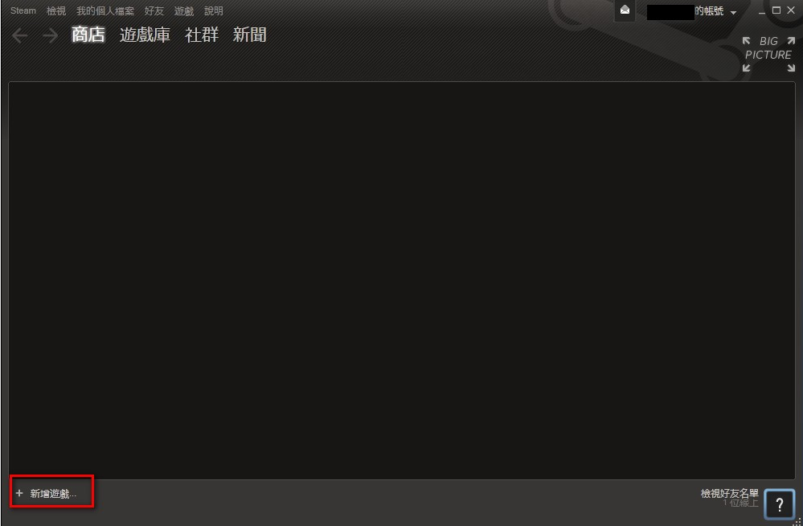

- Check “ Activate products on Steam”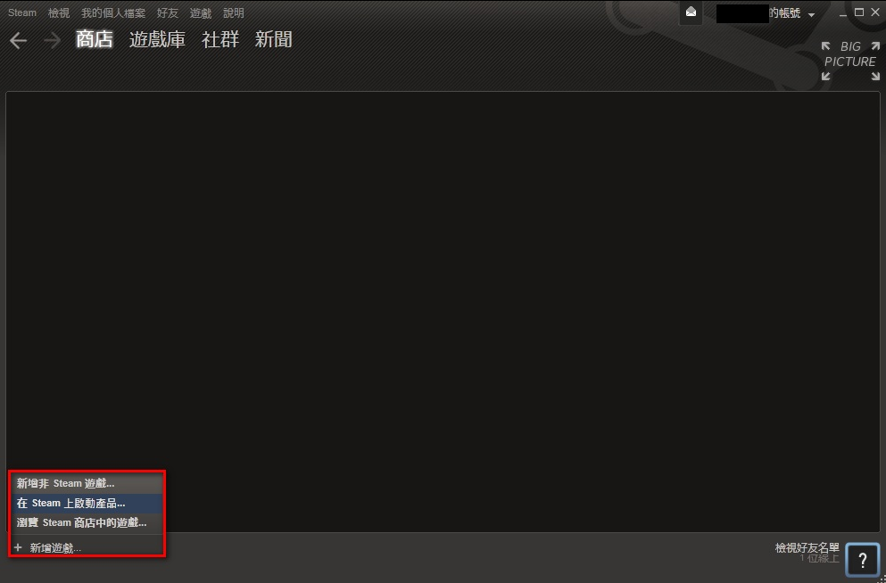

- Click “Next” at the product activation page

- Click “I Agree” at Steam Subscriber Agreement Page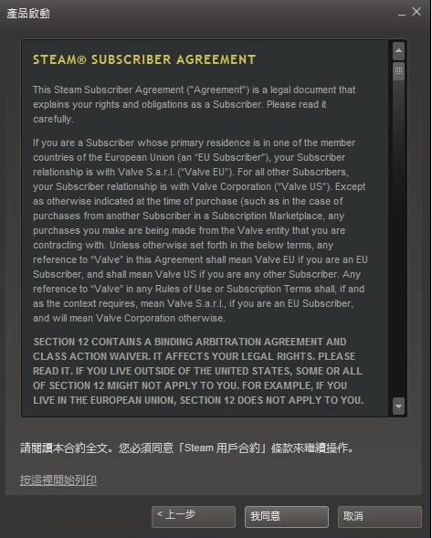

- Input your NBA 2K13 Game Code that came along with your ASRock motherboards
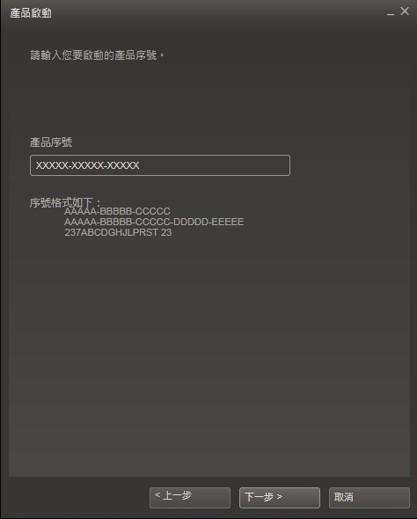

- You are ready to download NBA2K13 in Steam

If you do not have Steam account or not install Steam on your PC, please follow below steps:
- Please visit: http://store.steampowered.com
- Click the “Install Steam” at the upper right corner. 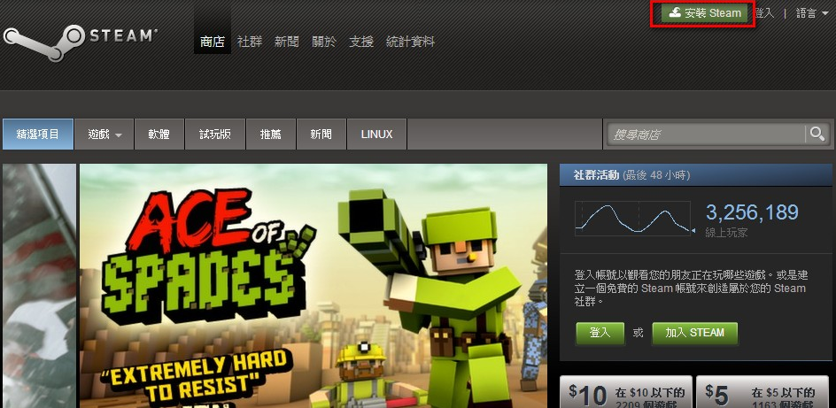

- Please follow the instruction on the webpage to download and install Steam client
- Please log into Steam when you finish the installation.
- Click “ Add Game”at the bottom right corner
- Check “ Activate products on Steam”

- Click “Next” at the product activation page

- Click “I Agree” at Steam Subscriber Agreement Page

- Input your NBA 2K13 Game Code that came along with your ASRock motherboards

- You are ready to download NBA2K13 in Steam

